PRCOMP FUNCTION AND INTEPRETATION

This is based on wine data set with a subset of 5 variables

Summary()

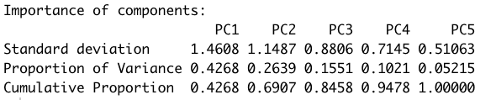

We for the first feature of PCA results: Variances of each component, and the proportion of the total variance of the original variables are given by the eigenvalues.
The variability of PC1 is 42.7%.

Print() or use loadings features

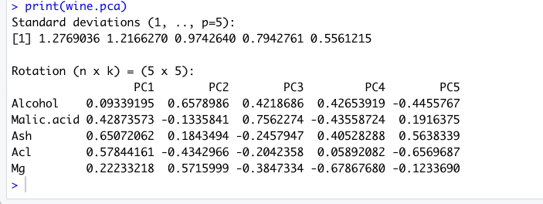

In this section, we look at the rotation we can see that, our scaled data is now combined into 5 principal components. These are values of eigenvectors. We can have our linear combination based on the values of eigenvectors

T1 = .093X1 + (.42)Y1 + (.65)Z1 + (.58)M1 + (.22)L1
…..
T5 = ….

The standard deviation values can be used to identify the variances of the components with by square the standard deviation.

Extract PC1 and PC2 and attach to our dataframe to examine the structure of our PCs. We now use x score feature of PCA function

We use cbind plot PC1 and PC2 onto the subset of our dataset -> bind them together. This is to plot our original dataset on to 2 PCs.

Using ggplot to visualise

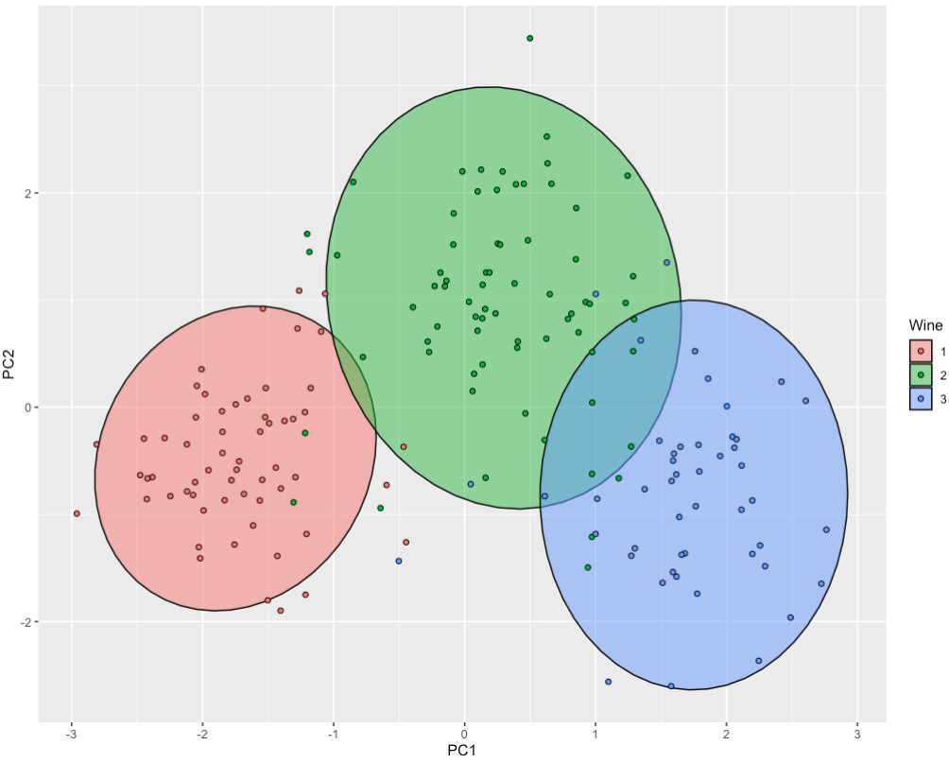

Now we can see that our dataset with 5 dimensions can be explained by 2 dimensions – 2 linear combinations of those variables and is able to separate 3 types of wines.

Now we want to know how much our dataset can be changed if using 2 PCs. So we look at correlations of variables and PCs.

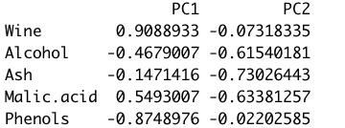

So an observation increases along the PC1, so does the Wine and Malic.acid.

In order to better understand the implications of our results, we plot the first 2 loadings

The first loading is essentially flat, so a component on this loading represents the average yield over the maturities. Same for the second component.

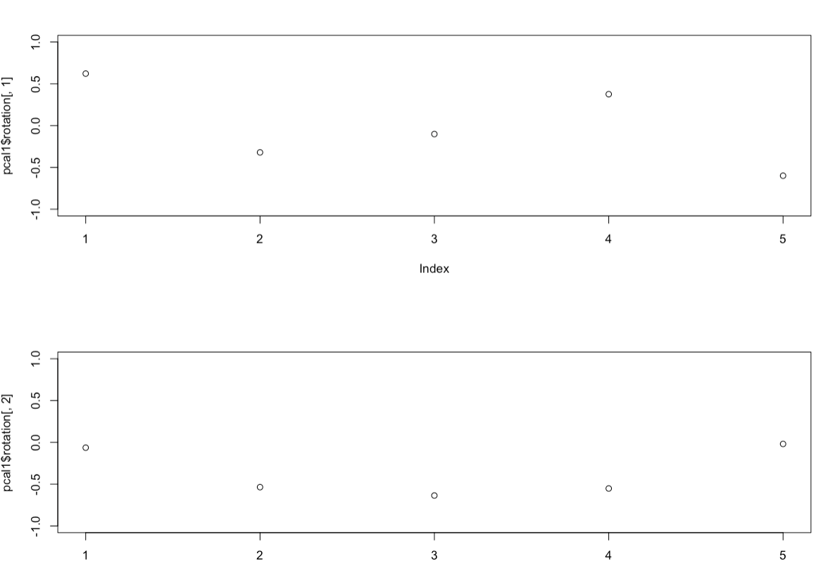

Summary of Interpretation

- The proportion of variance indicates how much of total variance is there in variance of a particular principal component. Hence, PC1 variability explains xx% of total variance of the data.
- Rotation values shown are same as 'loadings'.
- Considering rotations of PC1, one can conclude that which variables in the PC1 and PC2 are directly related, and what are the direction of these variables (negative values or positive values in rotation of PC1 and PC2).
- Give a name of latent variables (PC1, PC2) which may be affecting all of variables of PC1 and PC2.

